Introduction
After the declaration of examination results, many students are often left wondering where they lost marks and how they can improve their performance in future attempts. Obtaining a copy of the evaluated answer sheet can provide valuable insights into the assessment process, helping students understand their mistakes, identify areas for improvement, and develop a more effective examination strategy. Through the RTI Act, students can access their answer sheets and use them as a practical learning tool for achieving better results in subsequent examinations.

Why Should Students Obtain Answer Sheet Copies Through RTI?
Obtaining a copy of the evaluated answer sheet can be highly beneficial for students appearing for future examinations. It helps:
- Understand examiner expectations and the standard of answers required.
- Identify mistakes that led to loss of marks.
- Improve answer-writing techniques and presentation skills.
- Recognize weak areas requiring additional preparation.
- Avoid repeating the same errors in future attempts.
- Assess whether revaluation is necessary before spending time and money on review procedures.
- Develop a focused study strategy based on actual performance.
- Gain transparency and confidence in the evaluation process.
Rather than viewing the answer sheet as a record of past results, students can use it as a valuable learning tool to improve their performance in subsequent attempts.

Step-by-Step Procedure
The students are advised to follow the steps and file the application in between during the 10 P.M. to 7 A.M. for better and smooth filing.

- Go to the RTI Online Portal
Visit rtionline.gov.in → “Submit Request”. Register with email if you’re a first-time user.
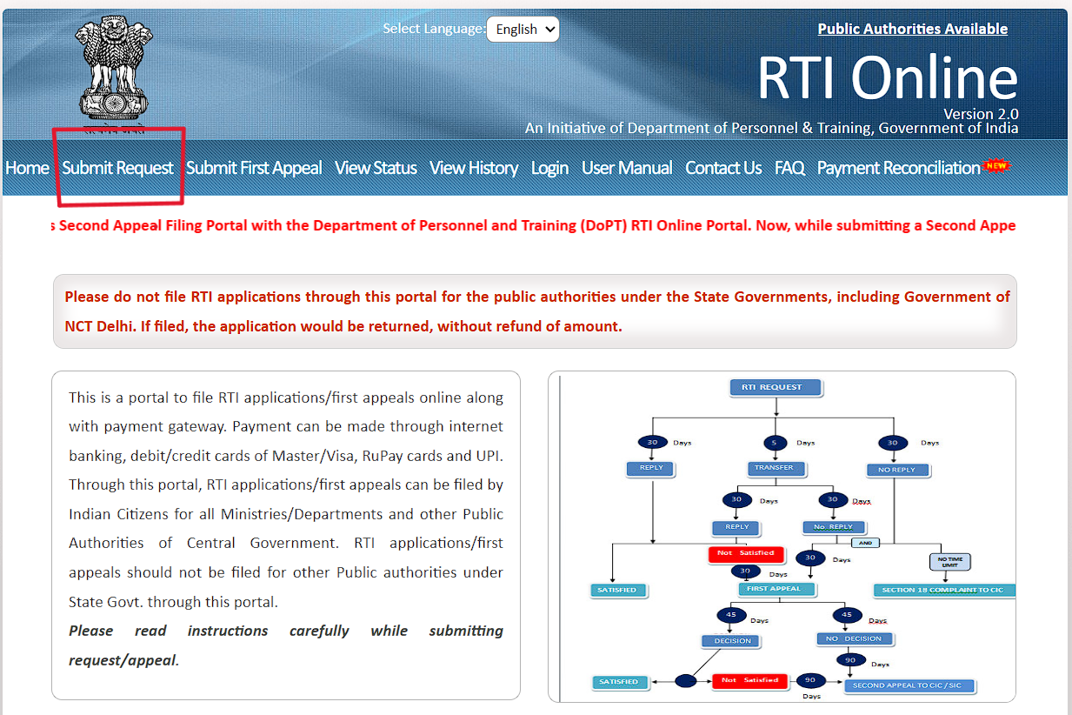

- Select ICAI as the Public Authority
Search and select “Institute of Chartered Accountants of India” from the dropdown.

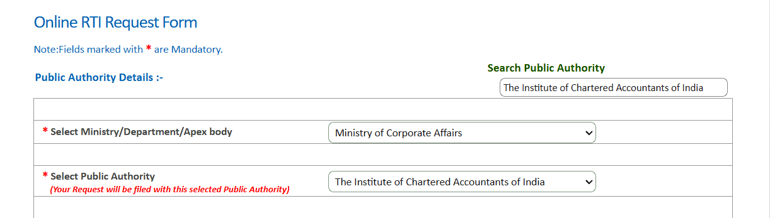

- Fill Personal Details Carefully
Use the same Name/Email/Phone as ICAI records to avoid mismatches and delays.
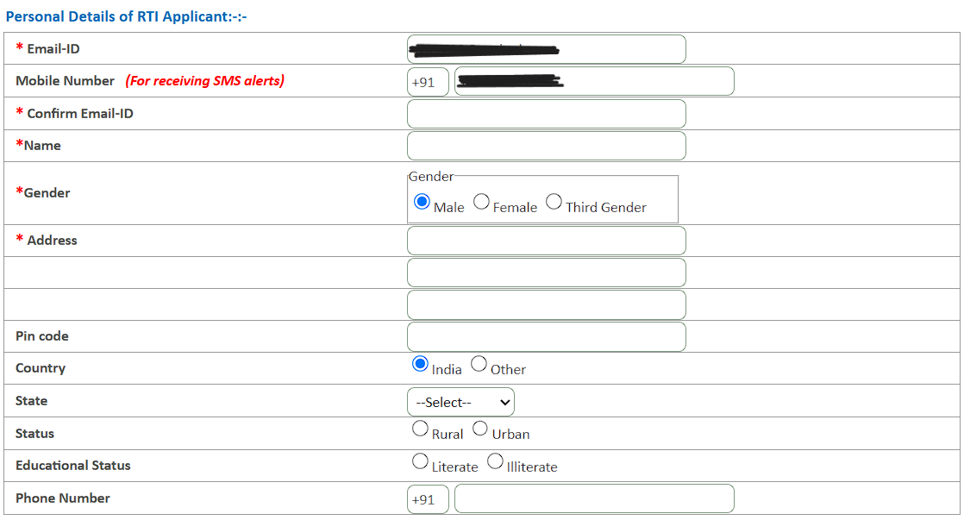

- Paste the RTI Application Template
Paste the template below and fill placeholders. Avoid special characters/dashes if the portal rejects them.
Only alphabets A-Z a-z number 0-9 and special characters, . - _ ( ) / @ : & ? \ % are allowed in Text for RTI Request application.

RTI Application Template — Copy & Paste
Subject: Request for Certified Copies of Evaluated Answer Books under RTI Act, 2005
Dear Sir / Madam, I hereby request certified copies of my evaluated answer books under the Right to Information Act, 2005. My examination details are as follows:
1. Full Name: [Your Full Name as per ICAI records]
2. Date of Birth: [DD/MM/YYYY]
3. Registration Number: [Your ICAI Registration Number]
4. Roll Number: [Your Exam Roll Number]
5. Examination: [CA Foundation / CA Intermediate / CA Final]
6. Session: January 2026
7. Contact Number: [Your Mobile Number]
I request certified copies of my evaluated answer books for the following papers:
1. Paper 01 - Financial Reporting
2. Paper 02 - Advanced Financial Management
3. Paper 03 - Advanced Auditing, Assurance & Professional Ethics
4. Paper 04 - Direct Tax Laws and International Taxation
5. Paper 05 - Indirect Tax Laws
6. Paper 06 - Integrated Business Solutions
I have attached a self-attested copy of my Admit Card as proof of identity.
Yours sincerely,
[Your Full Name]
[Date]

- Upload Self-Attested Admit Card
Upload a clear scan/photo of your May 2026 Admit Card with “Self-Attested” + signature.

- Pay ₹10 Online
Pay ₹10 on the RTI portal. This single fee covers all papers listed in your application.
Once you completed the above steps, you will get a reference number for successful filing of application. Your answer sheet copies will be sent to you via your E-mail Id given in the account creation. You will receive an E-mail for the answer sheet copies within 15-20 days.

Conclusion
For students, obtaining a copy of the evaluated answer sheet is more than just reviewing past performance—it is an opportunity to learn from mistakes and improve future results. By understanding how answers were assessed, identifying areas for improvement, and refining examination strategies, students can approach their next attempt with greater clarity and confidence. A small effort today in seeking transparency can lead to better preparation and improved scores in future examinations

